|  |  |  |
| --- | --- | --- |
| SCHOOL OF INFORMATION AND TECHNOLOGY | | |
| NAME: MAGNO, RONNIE | DATE PERFORMED: 08/22/24 | 50/50 |
| Section: IDC2 | DATE SUBMITTED: 08/22/24 |

# SYSADM1 – Introduction to File Systems in Windows and Linux

# Requirement:

* A virtual machine running Linux and Windows OS

# Instructions:

**Part A: Windows File System**

1. **Open File Explorer:** Click the File Explorer icon on your desktop or press the Windows key + E.
2. **Navigate to your Documents folder:** This is usually the default location for user files.
3. **Create a new folder:** Right-click in an empty space, select "New," then "Folder." Name it "Lab1_Windows."

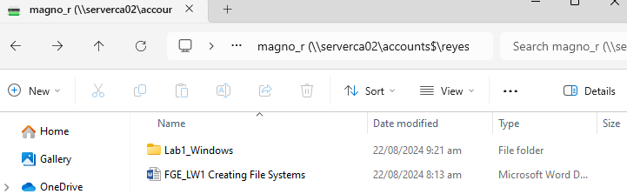

1. **Create a text file:** Right-click in the "Lab1_Windows" folder, select "New," then "Text Document." Rename it to "info.txt."

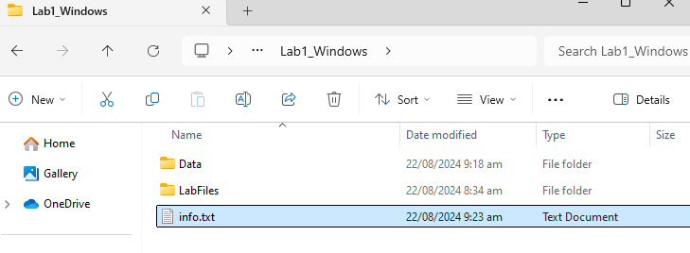

1. **Open the text file:** Double-click the "info.txt" file to open it in Notepad.
2. **Type some text:** Write a short paragraph about yourself or the purpose of the file.

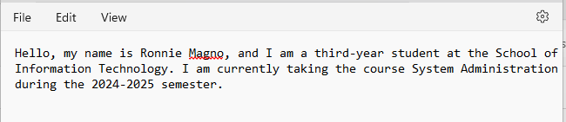

1. **Save the file:** Close the Notepad window and save the changes.
2. **Create a subfolder:** Create a new folder inside "Lab1_Windows" called "Data."
3. **Copy the text file:** Copy the "info.txt" file to the "Data" subfolder.

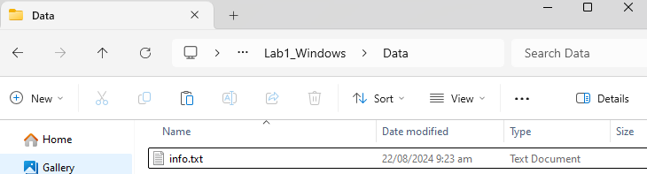

1. **Rename the copied file:** Rename the copied file to "data.txt.

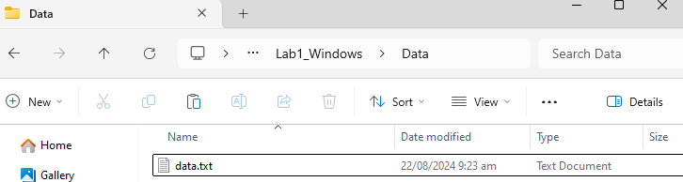

1. Create a folder named "LabFiles" with subfolders for each file type. Use the internet for the resources of the files listed below.

**LabFiles**

* 1. **Text**
     1. large_text.txt
     2. small_text.txt
     3. code.cpp

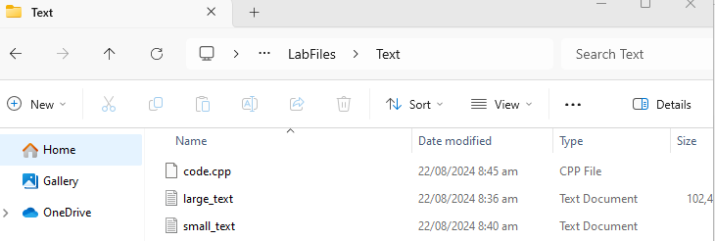

* 1. **Images**
     1. image1.jpg
     2. image2.png
     3. 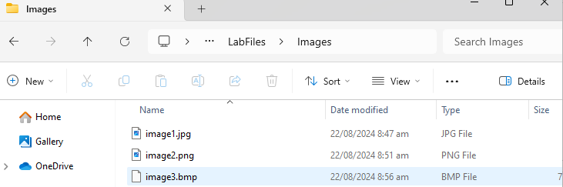image3.bmp
  2. **Audio**
     1. song.mp3
     2. 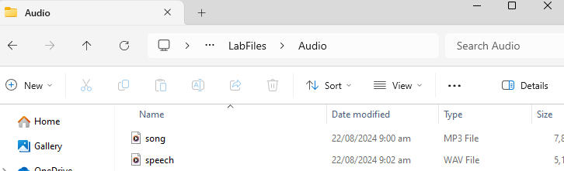speech.wav
  3. **Video**
     1. clip.mp4

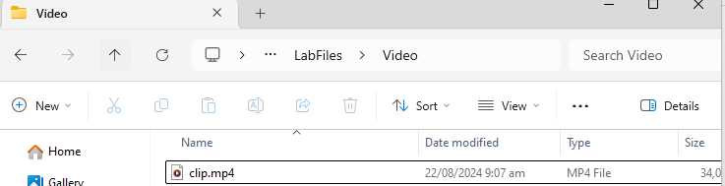

1. **Check file properties:** Right-click on the "info.txt" file and select "Properties." Explore the General, Details, and Security tabs to understand file attributes like creation date, size, and read-only status.

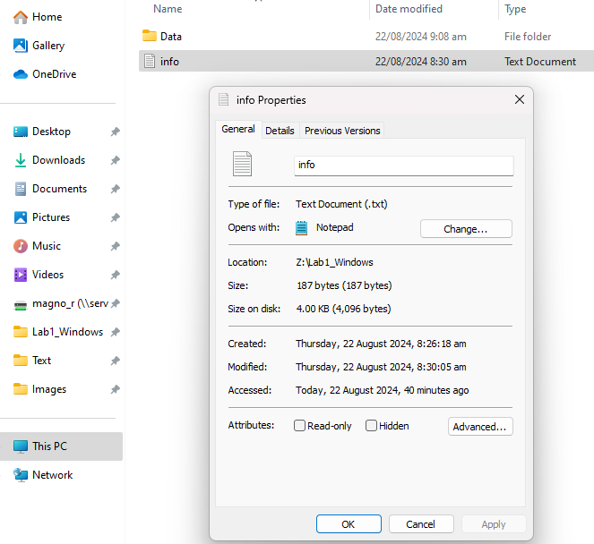

1. **Change file attributes:** Try changing the file attributes (e.g., read-only, hidden) using the Properties dialog. Observe the changes in File Explorer.

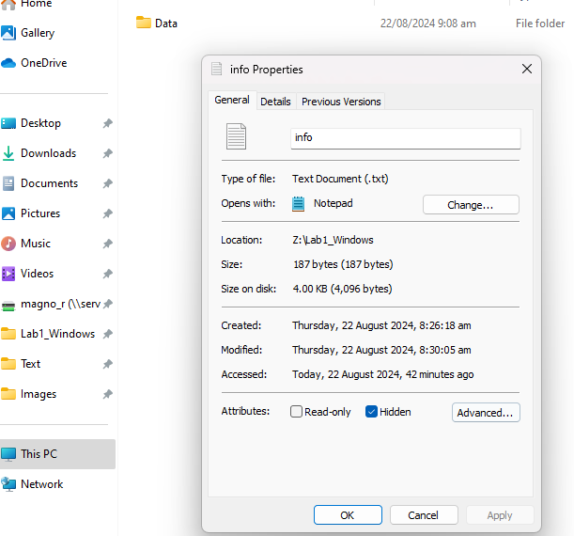

1. **Share the folder:** Right-click on the "Lab1_Windows" folder, select "Properties," and then the "Sharing" tab. Share the folder with a specific user or group, setting appropriate permissions (e.g., Read, Write, Full control)
2. **Create an archive:** Use WinRAR or 7-Zip to create a compressed archive of the "Lab1_Windows" folder.

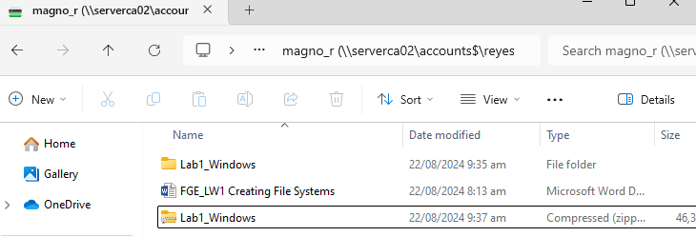

1. **Extract an archive:** Create a new folder, then extract the created archive into it.

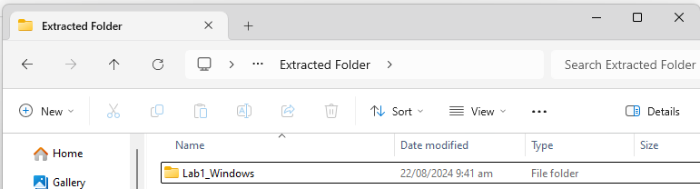

Part B. Create a log report structure

|  |  |  |  |  |  |
| --- | --- | --- | --- | --- | --- |
| **LOG REPORT** | | | | | |
| **STEP #** | **TASK** | **DESCRIPTION** | **RESULT** | **DURATION** | **STATUS** |
| 1 | Open File Explorer | Click the File Explorer icon or press Windows key + E | File Explorer opened | 2 minutes | Completed |
| 2 | Navigate to Documents folder | Go to default user file location | Documents folder accessed | 1 minute | Completed |
| 3 | Create a new folder | Right-click, select New Folder, name it "Lab1_Windows" | Folder "Lab1_Windows" created | 3 minutes | Completed |
| 4 | Create a text file | Right-click in "Lab1_Windows," select New Text Document, and rename to "info.txt" | Text file "info.txt" created | 3 minutes | Completed |
| 5 | Open the text file | Double-click "info.txt" to open in Notepad | Notepad opened with "info.txt" | 1 minute | Completed |
| 6 | Type some text | Write a short paragraph about yourself in Notepad | Text written and saved | 6 minutes | Completed |
| 7 | Save the file | Close Notepad and save changes | File saved with changes | 1 minute | Completed |
| 8 | Create a subfolder | In "Lab1_Windows," create a folder named "Data" | Subfolder "Data" created | 2 minutes | Completed |
| 9 | Copy the text file | Copy "info.txt" to "Data" subfolder | File copied to "Data" | 2 minutes | Completed |
| 10 | Rename the copied file | Rename the copied file in "Data" to "data.txt" | File renamed to "data.txt" | 2 minutes | Completed |
| 11 | Create "LabFiles" folder | Create "LabFiles" with subfolders for Text, Images, Audio, Video | "LabFiles" and subfolders created | 3 minutes | Completed |
| 11.1 | Text files | Download or create files: large_text.txt, small_text.txt, code.cpp | Text files added | 5 minutes | Completed |
| 11.2 | Images | Download or create files: image1.jpg, image2.png, image3.bmp | Image files added | 7 minutes | Completed |
| 11.3 | |  | | --- | |  |  |  | | --- | | Audio | | Download or create files: song.mp3, speech.wav | Audio files added | 5 minutes | Completed |
| 11.4 | Video | |  | | --- | |  |  |  | | --- | | Download or create file: clip.mp4 | | Video file added | 3 minutes | Completed |
| 12 | Check file properties | Right-click "info.txt," select Properties, review General, Details, Security tabs | File properties reviewed | 4 minutes | Completed |
| 13 | Change file attributes | Modify attributes (e.g., read-only, hidden) via Properties dialog | Attributes changed | 4 minutes | Completed |
| 14 | Share the folder | Right-click "Lab1_Windows," select Properties, Sharing tab, set permissions |  |  | Failed |
| 15 | Create an archive | |  | | --- | |  |  |  | | --- | | Use WinRAR or 7-Zip to create a compressed archive of "Lab1_Windows" | | Archive created | 3 minutes | Completed |
| 16 | Extract an archive | |  | | --- | |  |  |  | | --- | | Create a new folder, extract the archive into it | | Archive extracted successfully | 2 minutes | Completed |